**Ash Wednesday March 5, 2025, 6:30 PM**

*(*invites all who are able to stand) (****bold*** *text equals ALL speak)*

Prelude

**Reflection for Worship Today**

*This space and time is for you to contemplate the state of your soul and your continuing walk with Christ. Ask yourself: Am I moving forward on my discipleship journey? Am I prioritizing the things that will bring me healing and wholeness? Am I paying attention to the relationships that come with my faith, with God and neighbor? …the Lenten journey begins.*

**GATHERING TOGETHER**

One: Good evening, Church! I see you! **ALL: I am here!**

We gather together acknowledging one another with gratitude to God for the opportunity we have to worship in freedom tonight. Caldwell welcomes our shared ministry partners, the people of Our Lord’s UMC AND everyone who has come to worship this evening.

**\*Song *Sunday’s Palms Are Wednesday’s Ashes* TFWS #2138, vs 1**

*Call to Worship

**We come, aware of our sin, of all the ways we miss the mark.**

God welcomes you with compassion.

**We come, longing for restoration, to be made new.**

God surrounds you with grace and forgiveness, reconciling you to God and one another.

**We come, thirsting for reconciliation, to draw close to God and one another.**

God embraces you with love, reuniting us with God and one another.

**ALL: Sustain in us, O God, a willing spirit to return to the joy of our salvation as we journey together through the season of Lent.**

**\*Hymn *Sunday’s Palms Are Wednesday’s Ashes* TFWS #2138, vs 2,3**

**\*Unison Prayer**

**Gracious God, out of Your love and mercy You breathed into dust the breath of life, creating us to serve You and our neighbors. Call forth our prayers and acts of kindness, and strengthen us to face our mortality with confidence in the mercy of Your Son, Jesus Christ, our Savior and Lord, who lives and reigns with You and the Holy Spirit, one God, now and forever. Amen.**

**LEARNING TOGETHER**

Bell Choir: *What Wondrous Love Is This*  Arr. By Becky Perreault

Scripture Psalm 51:1-17 CEB

Lectionary texts: Joel 2:1-1, 12-17 Return to God; Isaiah 58: 1-12 The fast that God chooses; Psalm 51: 1-17 Plea for mercy; 2 Corinthians 5:20b-6:10 Now is the day of salvation; and Matthew 6:1-6, 16-21 The practice of faith

The Word of God, for ALL of us, God’s people. **Thanks be to God!**

Sermon *Sustain in Me A Heart of Repentance* Rev. Kelly Fowler

**RESPONDING TOGETHER**

Invitation to Observe A Holy Lent

**Responsive Prayer of Confession**

On this first day of Lent, we pause, look within, and examine our consciousness.

**Have mercy on us, O God, according to your steadfast love.**

Where we have neglected prayer, been apathetic in worship, found reasons to avoid generosity, or lacked compassion:

**Have mercy on us, O God, according to your steadfast love.**

Where we have colluded in the oppression of those who become invisible in their suffering, and ignored on the streets:  
**Have mercy on us, O God, according to your steadfast love.**

Where anxiety has eroded the gift of Your peace, and where we have cared too much about what others think:   
**Have mercy on us, O God, according to your steadfast love.**

A moment of silent confession

Words of Assurance

Pastor: As Lent begins, know that God understands how we struggle to stay open and compassionate. The invitation is not to focus on our inadequacies but on God’s gift of grace and love which transforms our hearts and minds. That gift is given to us again, here and now. Be encouraged.

**ALL: Amen.**

The Great Thanksgiving

**The Lord’s Prayer**  From the Ritual of the Former Methodist Church, UMH #895

**Our Father, who art in heaven, hallowed be thy name. Thy kingdom come; thy will be done on earth as it is in heaven. Give us this day our daily bread. Forgive us our trespasses, as we forgive those who trespass against us. And lead us not into temptation, but deliver us from evil. For thine is the kingdom, and the power, and the glory forever. Amen.**

The Blessing of Ashes

….**Amen.**

Moving into A Holy Lent

One: The peace of Christ be with you! **ALL: And, also with you!**

**\*Blessing Prayer**

**Merciful God, who meets us in our brokenness and leads us toward wholeness, through this Table fellowship, we thank You for Your blessing. We also offer our hearts, seeking renewal and transformation as we receive the ashes - symbol of our mortality and penitence. During this sacred Lenten journey, cleanse us from all that separates us from You and restore the joy of Your salvation within us. May our offerings bring hope and healing to others. Bless our giving and receiving as You continually renew us with Your grace on this journey. In Jesus’ name, we pray, let it be so.**

*Final Blessing

*Unison Sending Forth

**Created from dust, held together by God’s extravagant love, we turn away from sin, and leave tonight embracing God’s love.**

**\*Hymn *Come and Find A Quiet Center* TFWS #2128 vs. 3**

*Postlude

**++++++++++++++++++++++++++++++++**

Resource: discipleshipministries.com;

**Caldwell United Methodist Church**

**March 5, 2025**

**8504 Caldwell Road**

**Mukwonago, WI 53149**

**Office Phone: (262) 706-3167**

[**www.caldwell-umc-wi.org**](http://www.caldwell-umc-wi.org)

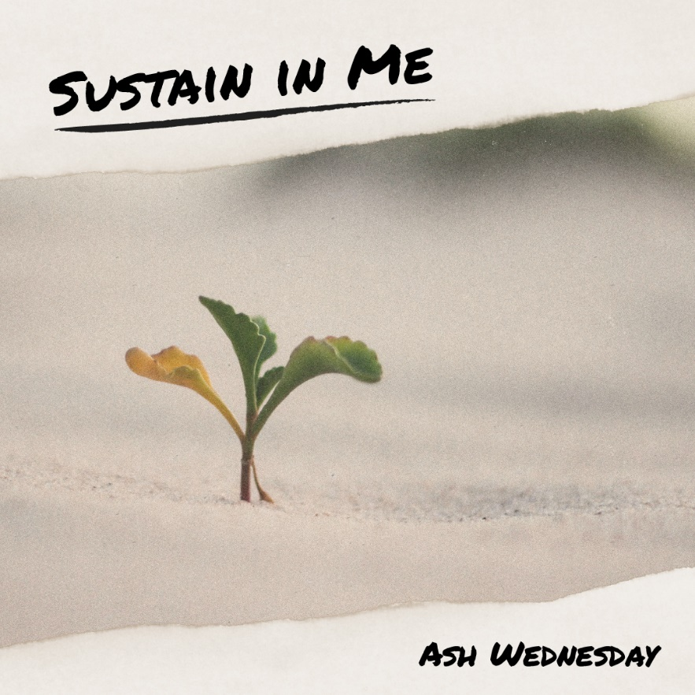

**Caldwell’s Mission:**

“*Bring Individuals to Christ*

*– Nurture Spiritual Growth – Invite Others*

*to Discipleship”*

**+++++++++++++++++++++++++++++++++**

**Contact info for Pastor Kelly**

**Cell #414-378-4012 for telephone calls and texts [text preferred]**

**Email:** [**pastorkelly@ourlordsumc.org**](mailto:pastorkelly@ourlordsumc.org)

**++++++++++++++++++++++++++++++++**

**Ministers:** All God’s People;

**Pastor:** Rev. Kelly Fowler

**Worship Leaders:** Terry Chipman, Esther Kalmerton

**Scripture reader**: Dave Moyer

**Social Media Host**: Terry Chipman, Esther Kalmerton

**Bell Choir Director:** Becky Perreault

**Director of Music**: Deanna Shimko

**Media Booth: Charles Herman,** Keith Chipman and Michael Koprowski